WATER POLLUTION IN CAU RIVER , THAI NGUYEN
In recent years, the economy of our country has been strengthened and developed towards industrialization and modernization. Along with this is the rapid growth of population and urbanization process. This has a positive influence on the development of socio-economy, however, this process also causes considerable pressures on environmental resources in Vietnam. The problems of land, water and air pollution ... has been becoming a great challenge. In which, water pollution, especially pollution in industrial zones, urban areas and factories... is currently one of the frustrating problems.
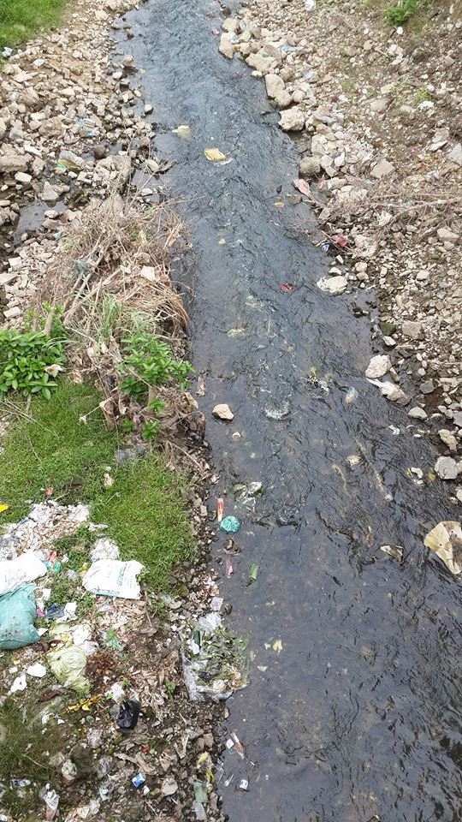
Waste being thrown everywhere nears the river
As a province with the developed mining and metallurgy industry, Thai Nguyen is also in the common state.
Currently, water pollution in Thai Nguyen has been in an alarming state. A typical example is Cau River flowing through the province's territory. Each day, each hour, the waste from residential areas, factories and industrial zones ... has been discharged directly into Cau River and many other rivers and streams without experiencing any dispose process, this makes water become stinking and discolored
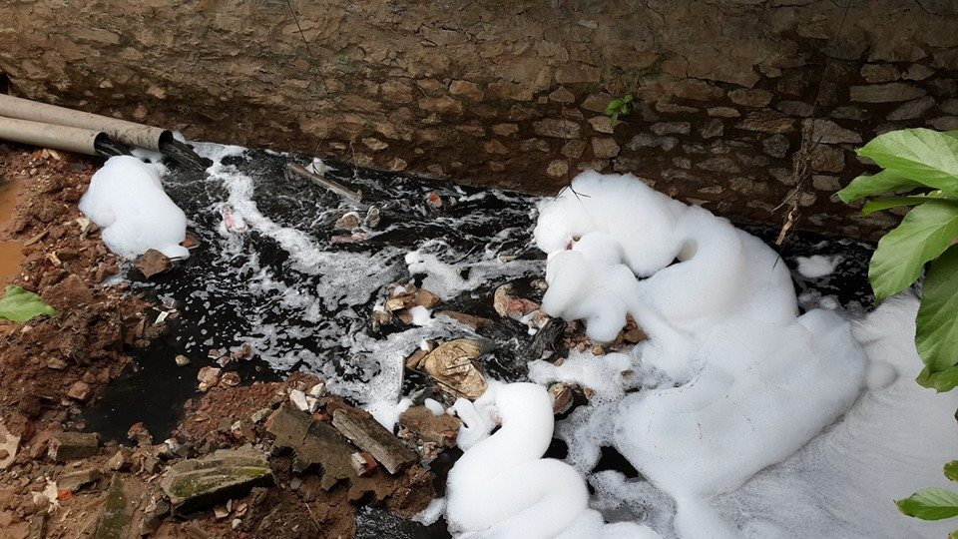
Waste water pipe in Quan Trieu Ward. (wastewater is discharged directly into the river causing water turned black and smelly).
According to the statistics of the Department of Natural Resources and Environment in Thai Nguyen, the total waste of metallurgy, steel fabrication equipment and machinery is about 1600m3/day. In which, the industrial wastewater of Thai Nguyen Iron and Steel Industrial Zone has the largest effect on the quality of water in Cau River. The industrial wastewater through two canals and rivers flowing into the river with the estimated traffic is 1.3 million m3 per year.
Water pollution affects many aquatic organisms, human health and economic development of society. First, high level water pollution can cause the loss of organisms, coastal flora and the balance of biodiversity. Next, clean environment is an ideal one for human pathogens such as dysentery, diarrhea, typhoid, hepatitis, ear inflammation ... or fungus harmful to fish, shrimp and other seafood affect to human health, economic damage. Furthermore, the waste dumped into rivers is causing the loss of aesthetics.
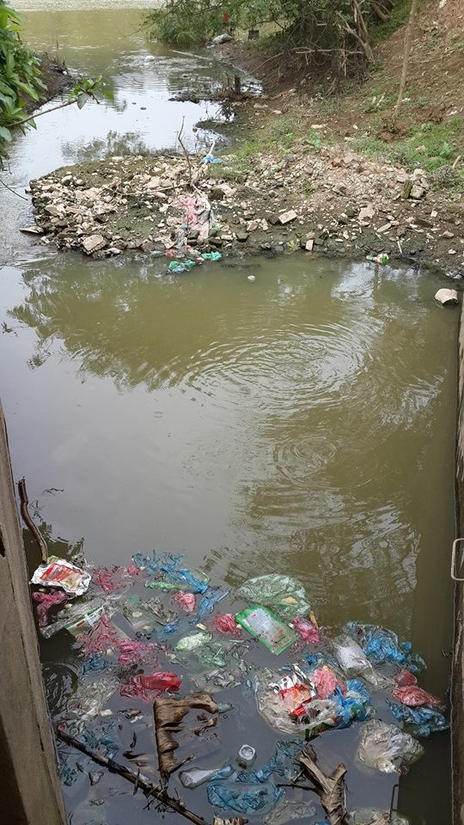
People throw garbage into the river causing water pollution and loss of urban aesthetics
The main reason for the environmental pollution is that the waste water and solid waste treatment systems has not been properly planned and highly concentrated, people are still littering, they even throw dead body animals into rivers and streams, creating more pathogens.
Although environmental issues have been implemented, they have not obtained satisfactory results because wastewater treatment systems are not synchronized reasonably .
Solving or reducing pollution levels are very difficult, thus, businesses , and organizations need to joint hands to invest clean industrial production , implement measures to prevent and minimize pollution , build wastewater treatment system in accordance with the standard in Vietnam. In terms of people, we need to have extensive propaganda so that they can fully comprehend the importance of protecting the environment, this will contribute to raise the awareness of each individual in our society .

