Pollution in Hoang Van Thu Paper Stock Company

Until visiting Cau River flowing Hoang Van Thu Paper Stock Company, we just can understand thoroughly sufferings of local residents. Stagnant sewage in drains released into lake and smells fetid whenever it is scorching. The polluted situation impacts seriously on health and daily activities of inhabitants who live in and around the company.
Hoang Van Thu Paper Stock Company, formerly the Dap Cau Paper Company, was built in 1913 in Dap Cau - Bac Ninh. Throughout its long history, the company has made outstanding contributions in protecting and building our country. It is the first company in nationwide has ever produced money printing-paper during the French war, the first company of Democratic Republic of Vietnam has ever managed paper company, the first company of the paper industry has ever registered in producing paper cement. The company was awarded the “Hero in the state armed strategy”. Beside the economic and social values, which provided by the company, there are still some problems existing and having negative impacts on the environment due to waste resources, especially sewage.
According to investigation of Thai Nguyen Department of environment and resources, sewage from Hoang Van Thu Paper Company is black and smelly. It also contains many poisonous chemicals such as Sodium hydroxide, Cl, Lignin and so on. The content of BOD and COD in sewage is higher than limited concentration 10 to 15 times. The sewage is not treated before releasing into Cau River, which causes serious pollution. 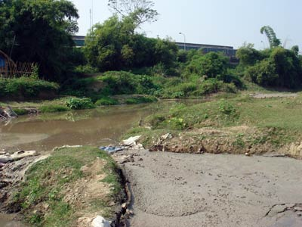
Waste from Hoang Van Thu Paper Stock Company discharge direct to Cau River
Since the establishment, Hoang Van Thu Paper stock company has increased output capacity and advanced in production line as well as in waste treatment. Explaining for the above pollution situation, offices and organizations reported that the major cause is that material basement and sewage treatment system are not advanced with the corresponding technology development.
From the actuality of paper industry of our country in general and Hoang Van Thu Company in particular, it can be clearly seen that investigating the real and proposing solutions for sewage treatment of Hoang Van Thu Company are extremely necessary. With the target of investigating sewage treatment system of Hoang Van Thu Company, there is a must that we propose some solutions for improving sewage treatment effect of Hoang Van Thu Paper Company in order to ensure the environmental standard of sewage treatment before releasing sewage into Cau River.
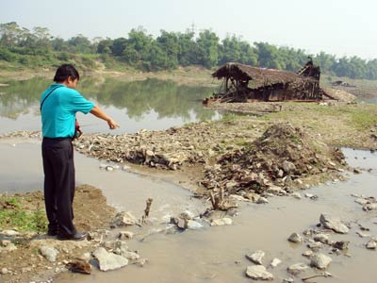
Polluted water joint Cau river next to Hoang Van Thu Paper Stock Company

