ENVIRONMENT POLUTION AND THE HYPOTHESES

In recent years, Thai Nguyen has seen a significan enhancement in the field of industry and services especially in the central area. However, due to numerous reasons, the development in industry, urbanization, mining, etc, has influenced significantly to the purity of the surrounding, particularly, the water.
The decline in the quality of water wil eventually reduce other natural resources. This is currently affecting the daily routine of the residents, the socio-economic advancement in Thai Nguyen
- Status
- Surface water
Surface water is heavily polluted, especially in Cau River, every year it has to bear approximately 35 million cubic metters of sewage or untreated waste water from over a thousand of enterprises, manufactures or hospitals,...
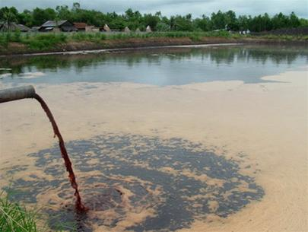
Untreated waste water being released in to the river
Besides, every year, over 15 million m² of waste water from domestic use is dumped into the river. “according to a reseach, the BOD5 concentration in the sampled water in Gia Bay, Thac Huong dam, Cau May has exceeded the limit from 1,08 to 9,5 times; COD exceeded 1,2 to 5,8 times, NH4 is 1,34 to 20 times over the standard figures. Meanwhile, the allowed number for all of the above substance is 0”
- Ground water:
Môi trường There has been evidence of pollution in the ground water, however, it is only a local issue occuring in Quang Vinh Ward (Thai Nguyen city) witht the concentration of Xyanua exceeding 1,9 to 12,9 times in compared to the standard.
Among all the manufactures and industrial complexes in Thai Nguyen, about 90% of the has not installed the water treatment system and the provided the adequate facilities as well as the infrastructure for the safety requirements.
- The impacts of water pollution
A countless number of diseases are connected with water pollution. Among these, typhoid, liver cancer, enteritis, encephalitis, ascarid as the most popular. Apart from this, respriratory diseases, stomach rash are also resulted from water pollution.
The ecosystem in Thai Nguyen is day-by-day being polluted. Many areas are experiencing heavy pollution. Therefore, a close-up look at the current status of the environment to point out the causes as well as some recommendations for the issue of environment pollution protection in Thai Nguyen is of crucial importance.
In addition, during the rainy season, the central part of Thai Nguyen city is usually flooded. The drainage system of the city is rather obsolete and substandard. Sewage from individual households, offices is released directly to the streams or rivers without treatment, which has worsen the pollution situation in the area. Hence, the construction of a modern and reliable drainage system in the area of Thai Nguyen city is of vital importance.
- Solutions
The project “building the drainage system in Thai Nguyen” has been approved by the provincial people’s committee in the Decision No. 1352/QĐ-UB on 11 July 2007. The aims of the project are to prevent flooding and improve the conditions of the surounding environment in 9 wards: Trưng Vương, Phan Đình Phùng, Túc Duyên, Gia Sàng, Hoàng Văn Thụ, Đồng Quang, Quang Trung, Quán Triều and Quang Vinh. This is one of the largest scale project being implemented with the total area of 1200 ha among 100.000 people
Moreover, the provincial people’s committee is coperating with the Department of Natural Resources and Environment in Thai Nguyen to conduct a project called “Enhancing, dredging the Coc stream in Cam Gia Ward, Thai Nguyen city” in 2011
These projects has gradually altered noticeably the infrastructure in the central area of Thai Nguyen, which helps the residents with their daily operations. The improvements in the environment mean that the people will benefit a lot from the project since their costs on medical, hygience and other relating factors will be remarkably reduced. The projects need more investment both from national and international to improve the environment in general and the healthcare of the people in particular. This will also bring about a boost in the socio-economy of the province.

REFERENCES
- Official dispatch No. 185/SXD – BQLDA of Thai Nguyen Provincial Department of Construction on “The proposal of establishing public welfare enterprises”
- http://baothainguyen.org.vn

